You do not need to need to be in this Folder unless you want to intergrate your twitter bot into Discord. If so. Stick around :)

1) Complete all steps in setting up Tootbot like normal. Please make sure that it is posting like it should. Once you are done come back to this folder

2)Go into the Discord.py-async Folder and you should see this. Open CMD and CD in the Folder and run pip3 install -r requirements.txt. Then Close CMD

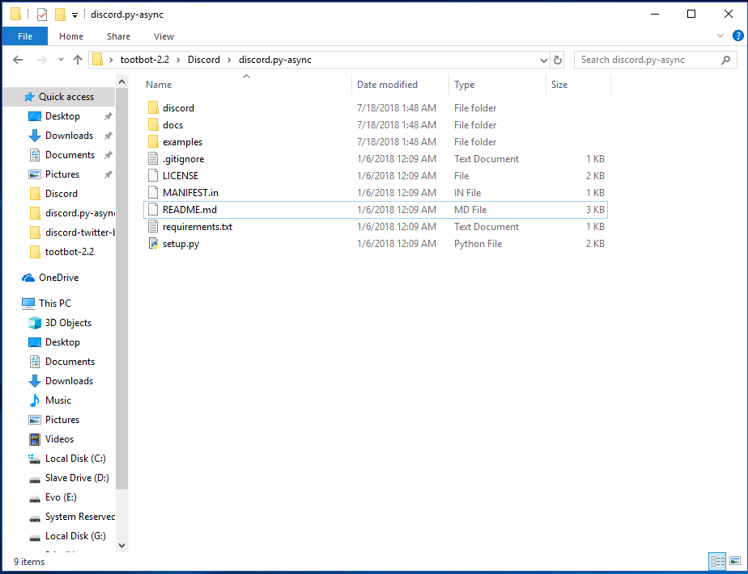

3) From here Open Discord and go to the server that you want to put the bot in and go to Webhooks

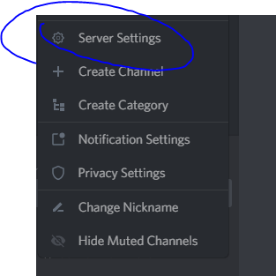

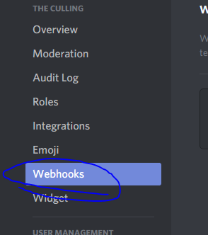

4) from here go to Create Webhook

5)Name it whatever you want and select the Channel that you want it to post in. I would make a brand new Channel for it. Slap a png for the ICON and copy that webhook URL somewhere that you can find it very easy. You will need it soonish. Click save then Kill Discord 100% Using Task Manager

6)Go back to the folder and open up CMD and cd into the folder that you are holding the discord.py-async folder in as Admin

7) Once you do Run

$ git clone <https://github.com/Rapptz/discord.py>

$cd discord.py

$python -m pip install -U .[voice]

8)You are now done in this folder. Now make your way over to the other Discord Folder I have put in here named discord-twitter-bot-master.

9) Run CMD as Admin once again and Cd into the folder you are now in.

10)type “Launcher.py” and a menu will pop up

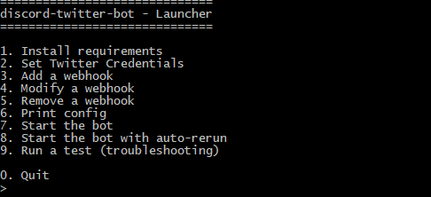

11) press 1 and then enter. This may take a minute. This should only fail if Discord if not fully closed. If it failed reopen and force kill Discord again.

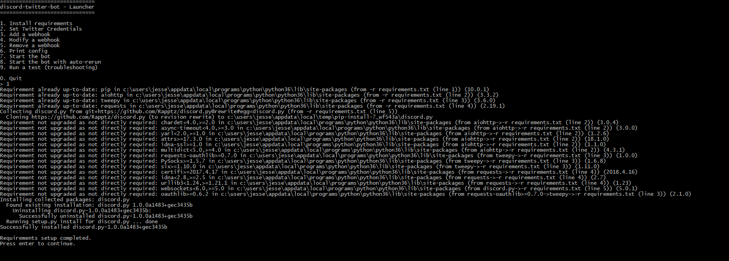

12)Click enter once it finishes and it will bring you back to the menu. Then click 2. It will ask you for Twitter API keys. YOU MUSH USE THE SAME AS YOUR TOOTBOT’S! These maybe found at app.twitter.com

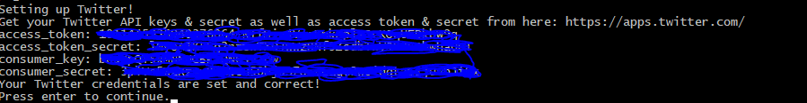

13) Then click 3 to “add a webhook” and chose Twitter Id’s

14)Type in the Webhook Url that you copied at the start and press enter

15) Go to Gettwitterid.com and type in the username of the acct without the @ and it will spit back a number

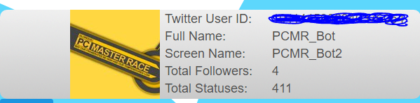

16) put that number in the Spot where it asks you for the Twitter Id and press Enter

17)respond to the next 3 questions with True/False based on how you what your bot set up.

18)Then click 0 to get back to the main menu

19) open up Discord and get into the server that you want the bot as well as the Channel that you chose before. (don’t close Launcher)

20) go back to the launcher and press 7 to start the bot. Once it is started start Tootbot. And it should then Take the post from your Twitter to the Discord Channel of your server

